PLS stage on the MCM3000 was analyzed. Figures 1 and 2 show the waveforms as the system drivers. With the new PLS xml on the MCM301, the same ramp-up and approximate current draw was observed. Figure 3 shows the ramp-up when applied with a max-speed (300) move with an acceleration of 50.

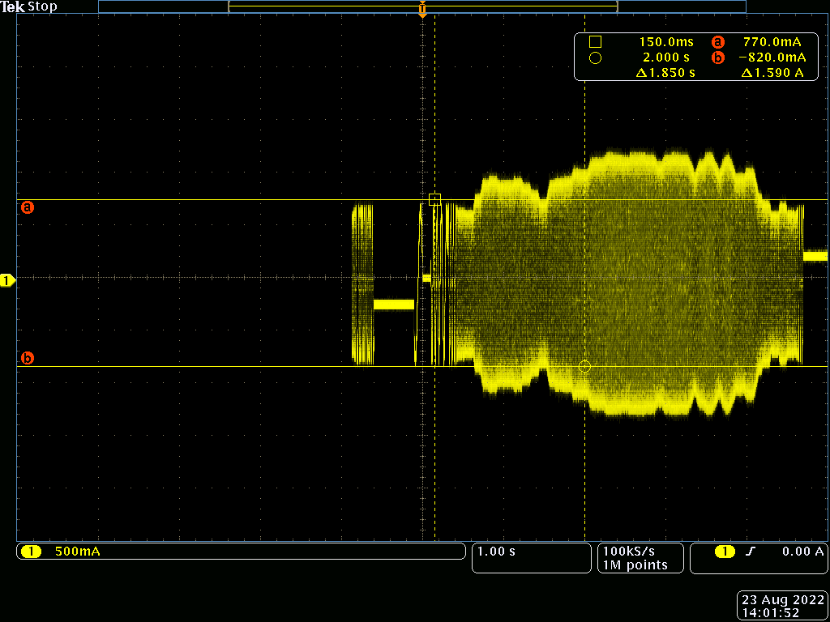
Figure 1: Joystick MCM3000 Driving, Low Speed Current

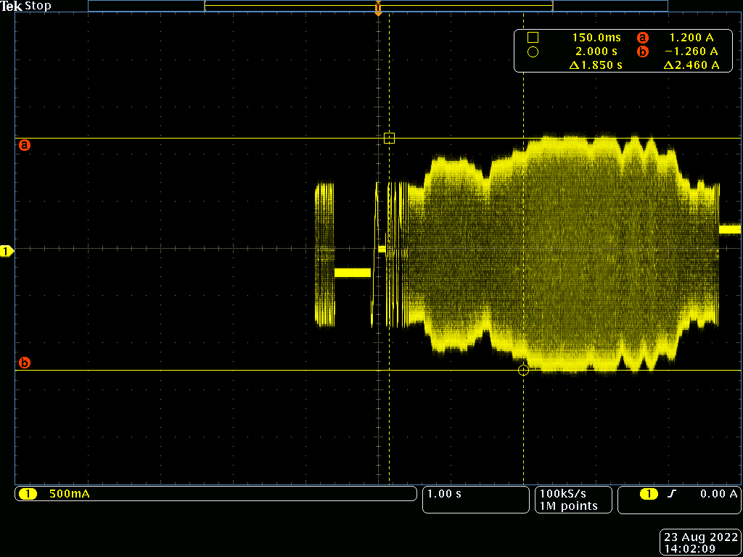
Figure 2: Joystick MCM3000 Driving, High Speed Current
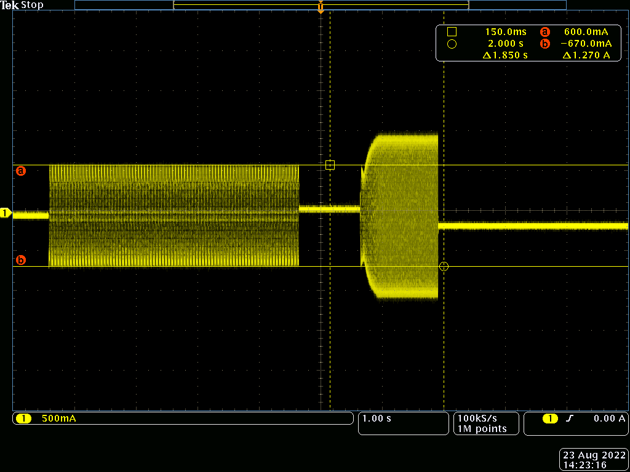
Figure 3: UI MCM301 Driving, Low Speed Current

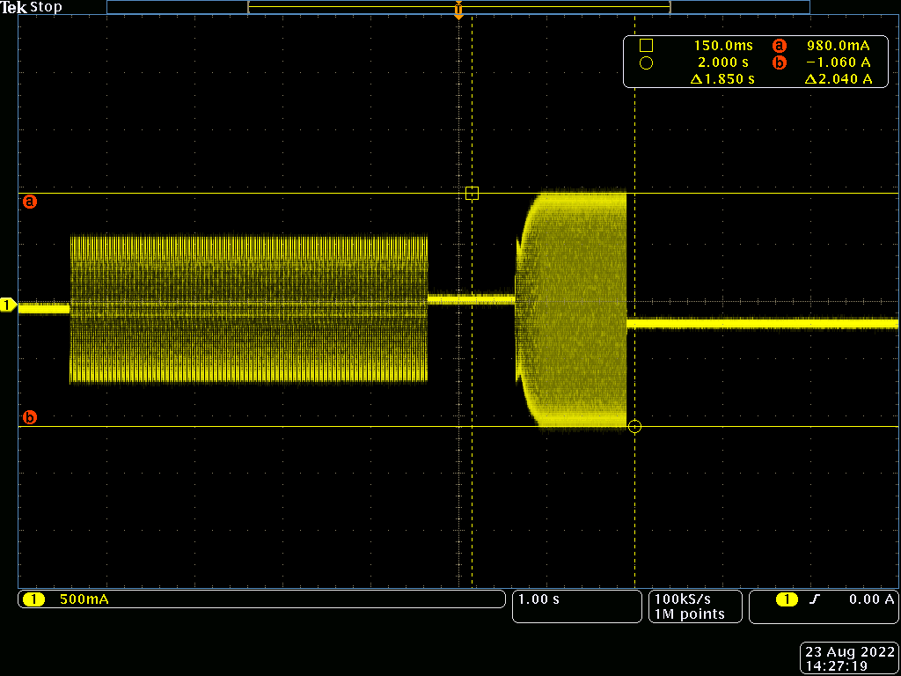
Figure 4: UI MCM301 Driving, High Speed Current
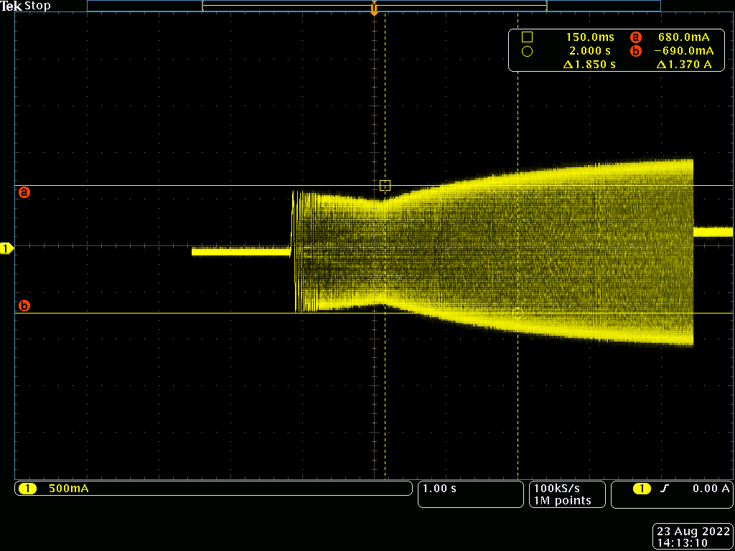
Figure 5: MCM301 PLS Driving Ramp Up

Table 1: Current Draw Comparison
 | Low Speed Current Draw (A, pk-pk) | High Speed Current Draw (A, pk-pk)
MCM3000 | 1.590 | 2.460
MCM301 (as of 8/24/22) | 1.270 | 2.040

